

*Version 23.1.0 for Salesforce Commerce Cloud – SFRA Test Cases*

# **Test Cases**

AirRobe developers will configure the styling to suit the storefront’s styling and the location of the Widgets on the page.

**Single Opt-in Widget**

The Single Opt-in Widget should render on the PDP page.

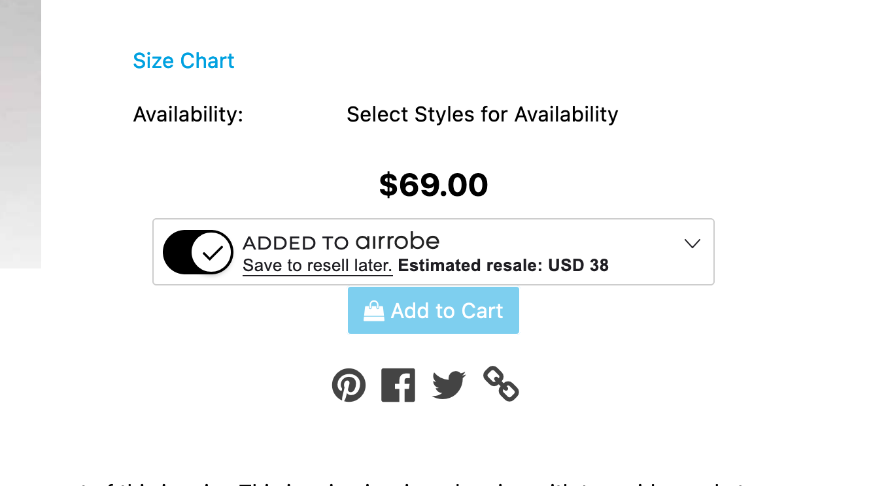

The following behavior should be possible:

* **On Load** - This is the state of the Single Opt-in widget upon load. It should be collapsed, in the opt-out state, with "Add to airrobe" showing, and the potential value loaded in by an API call to the Price Engine.

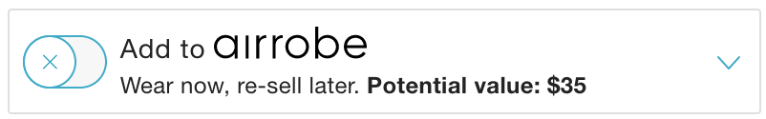

* **Opted In** - This is the state of the Single Opt-in widget when the user opts the product into AirRobe. It should be collapsed, in the opt-in state with "Added to airrobe" showing.



* **Expanded** - This is the state of the Single Opt-in widget when the user expands the widget by clicking on the chevron. It should expand to show this text. Clicking “Learn more” will display the popup.

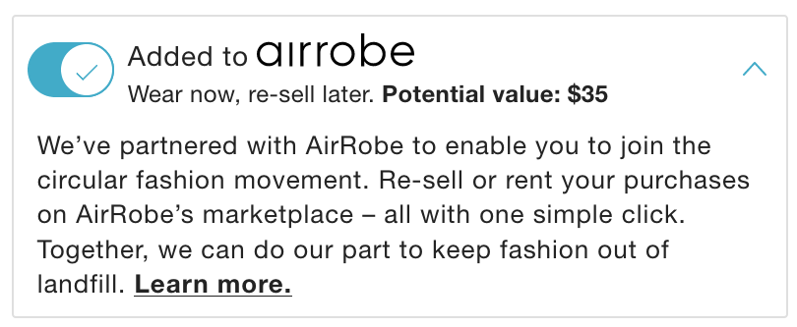

The widget should receive the following props with brand being optional.



**Multi Opt-in Widget**

The Multi Opt-in Widget should render on the mini-cart and full page cart.

Mini-cart

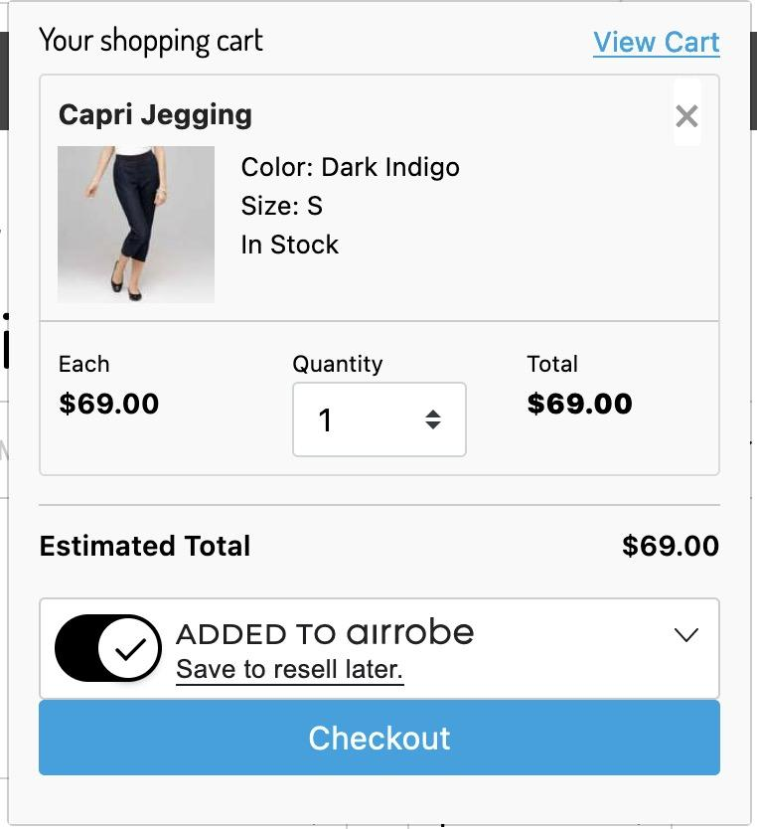

Full page cart

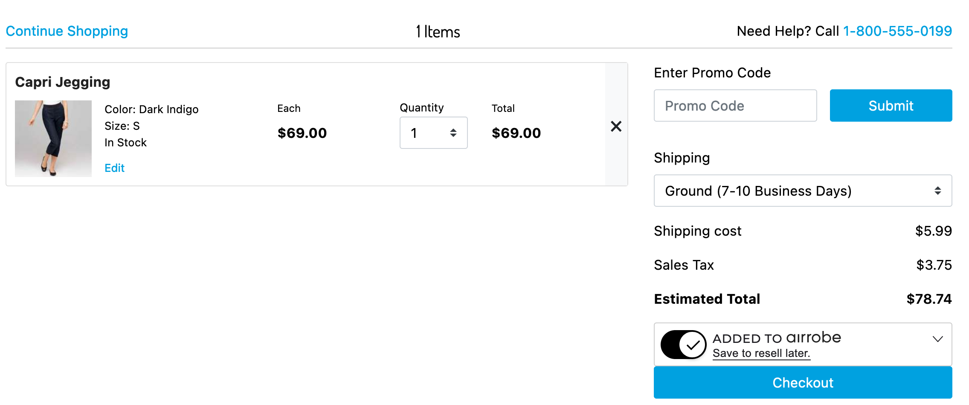

The Multi Opt-in Widget has all of the behavior as the Single Opt-in Widget except it doesn’t display the “Potential value”

The widget should receive the following props:



The popup is a part of the functionality of the Single Opt-in Widget and the Multi Opt-in Widget and looks like the following:

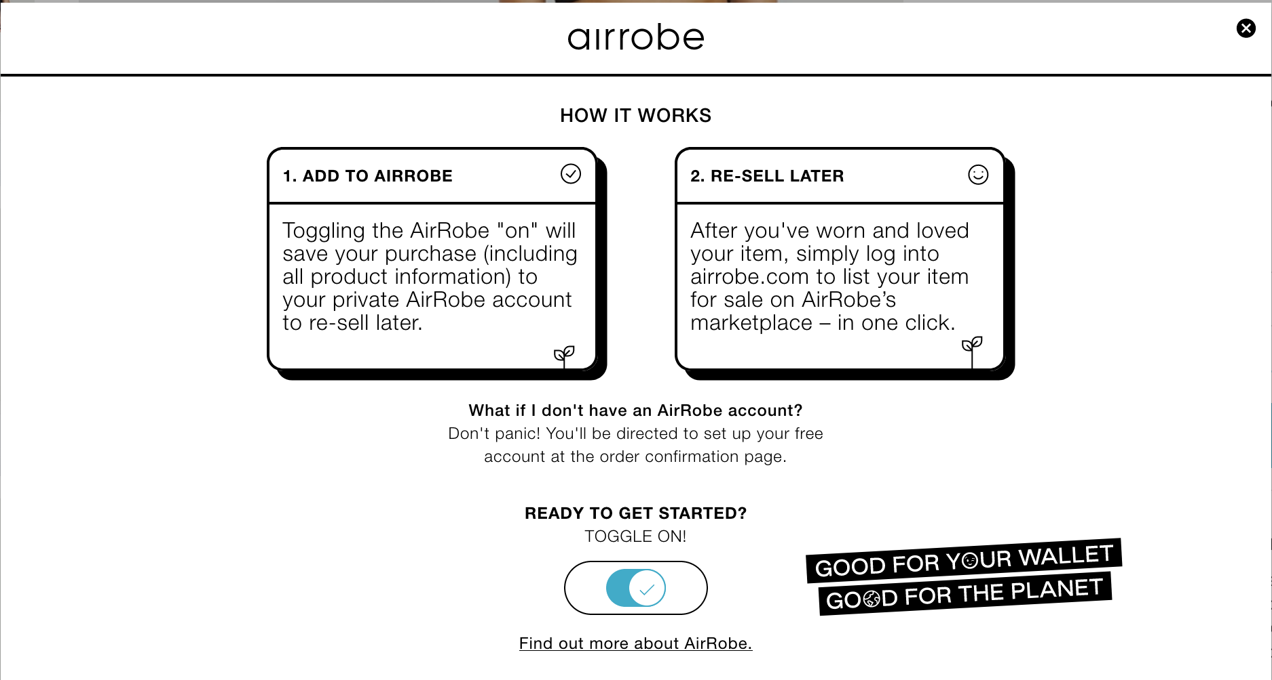

It has an Opt-in/Opt-out toggle and clicking on “Find out more about AirRobe” will open up another tab that links to information about AirRobe. Closing the popup is done by clicking the cross or clicking outside of the popup.

**Confirmation Widget**

The Confirmation Widget should render on the confirmation page if the shopper has opted in at least one product. This will send a request to AirRobe’s identify_order endpoint that will ingest the order into the AirRobe system as an opted-in order.

The Confirmation Widget should not render on the confirmation page if the shopper has opted-out for all products. The widget, even though not rendered, will send a request to AirRobe’s identify_order endpoint that will ingest the order into the AirRobe system as an Opted-out order. The Confirmation Widget can be in the following two states:

* This is the state of the Confirmation widget when the user hasn't activated their account in AirRobe.

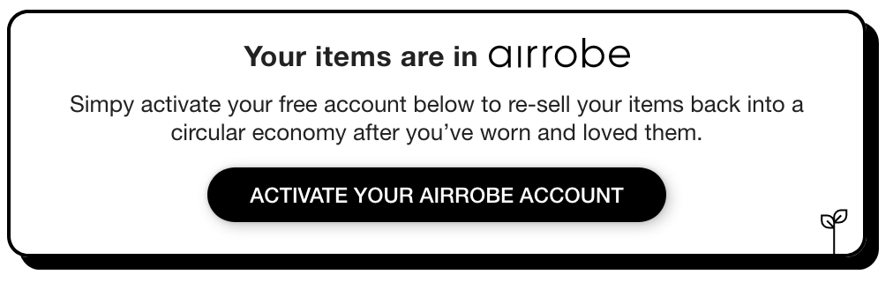

* This is the state of the Confirmation widget when the user has activated their account in AirRobe.

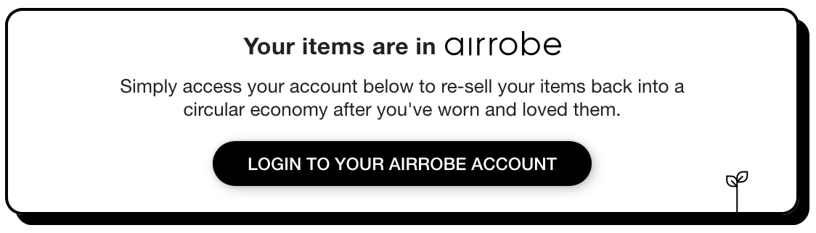

The widget should receive the following props:

